Power Point O365 Training
By Muthana Alalaki
May 28, 2018
Oxfam
https://www.oxfam.org/

Add and format text

Add text to slides
In PowerPoint, you can add text to your PowerPoint slides with text boxes and shapes.
Add a text box
- Select Insert > Text Box.
- On the slide, select and drag where you'd like to put your object and start typing into it.
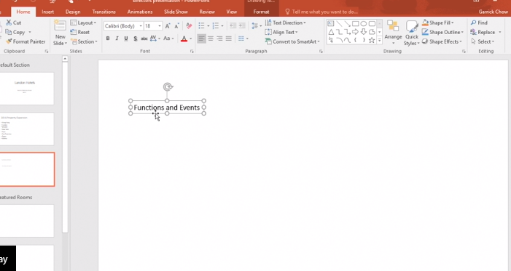
Note: The text box will shrink to fit the size of the text you're using, but its eventual height and width will wrap to the size you created.
Add text to a shape
- Select Insert > Shapes, and then select your shape.
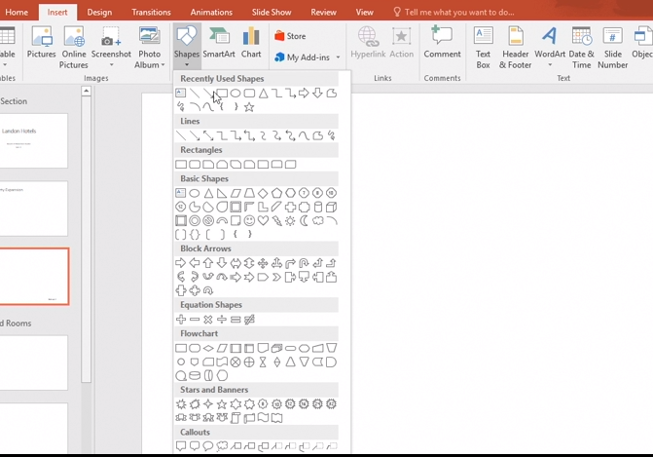
Note: To add text to a shape, you must select a closed shape, such as a rectangle, arrow, or circle.
- Select and drag where you'd like to put your object and start typing into it.
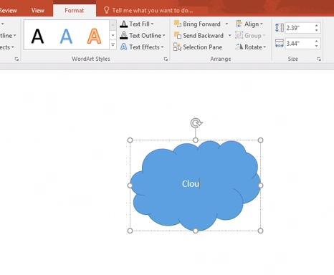

Format lists on slides
Change the size, font, and text style in your PowerPoint presentation to add emphasis and to highlight content.
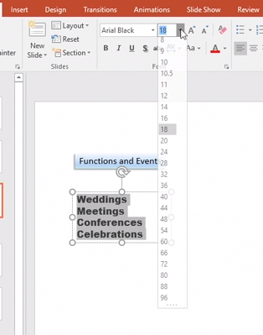
Format text in a placeholder
- Select the placeholder text you want to format.
- On the Home tab, select a formatting option: Font, Font Size, Line Spacing, Bold, Italic, and more.

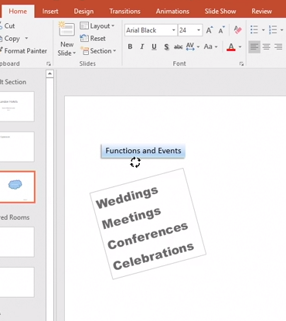

Note: If you'd like to change the position of your placeholder box, select the placeholder's rotate handle, hold Shift, and move the rotate handle in your preferred direction.

Copy and paste text into your presentation
- Select the placeholder that you'd like to copy text to.
- Copy and paste text from another source like a Word document.
- In PowerPoint, right-click and select a Paste Option for your text:
  - Use Destination Theme - Use the current theme's formatting.
  - Keep Source Formatting - Use the original formatting from Word.
  - Picture - Paste text in as an image.
  - Keep Text Only - Use no formatting for your copied text.
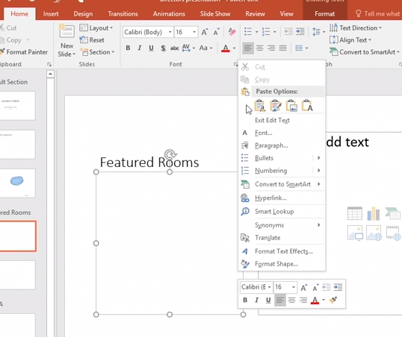

Format lists on slides
Bulleted lists focus your message to your audience, and help them follow along with your key talking points.
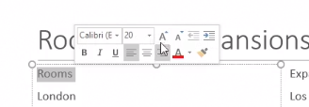
Create a bulleted list
- To format the title, select the text, and change the font style to what you'd like.

- To insert a bullet, place the cursor at the end of a bulleted line, press Enter, and start typing.
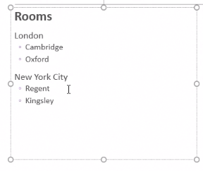
- To create a sub-bullet, place the cursor in front of the text, and press Tab.

- To delete a bullet, press Backspace, or select the line and press Delete.
- To demote a bullet, or un-bullet it, place the cursor in front of the text and press Shift + Tab.
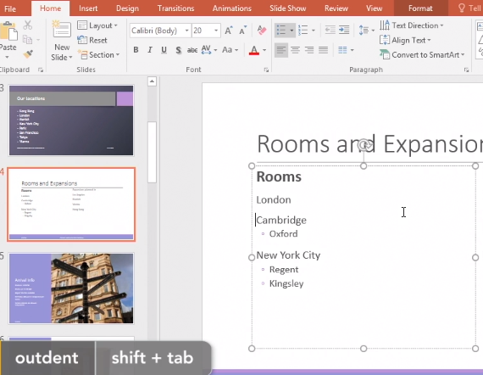
- To change the bullet style, on the Home tab, select the Bullets down-arrow, and select a bullet style.
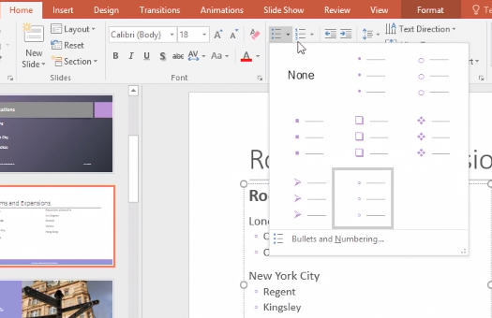
Select Bullets and Numbering... for more options, or to change the size and color of the bullets.
Create a numbered list
- To format the header, select the text, and change the font style to what you'd like.
- Select the lines of text that you'd like to number.
- On the Home tab, select Numbering .
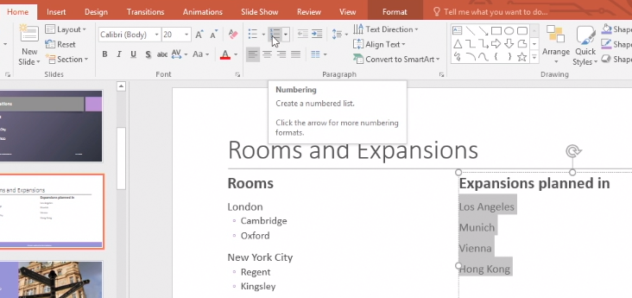
- To insert a numbered item, place the cursor at the end of a numbered line, press Enter, and start typing.
PowerPoint automatically renumbers the list. You can also delete a numbered line and PowerPoint renumbers the list.
- To change the numbering style, select the Numbering drop-down, and select a numbering style.
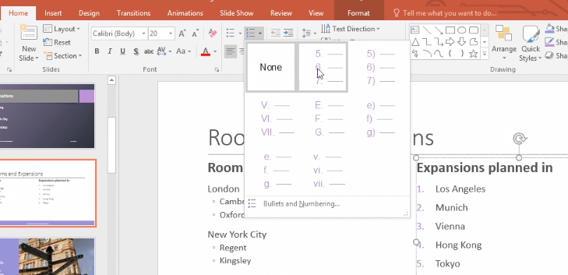
Select Bullets and Numbering for more options, or to change the size and color of the numbers.

Check spelling in your presentation
As you work on a presentation, PowerPoint automatically checks spelling and basic grammar and you can check the spelling of an entire presentation with ease.
Fix spelling as you work
- Right-click on a word with a red squiggly line underneath.
- Select the correct spelling from the list of suggestions.
Or you can choose:
  - Ignore All: Ignores the error and removes the red squiggly line.
  - Add to Dictionary: Adds the spelling to the dictionary so that spelling will not show an error in the future.
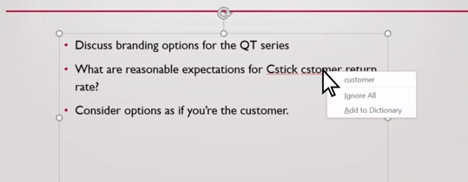
Check your entire presentation
- Select Review > Spelling.
- In the Spelling pane, select the correct spelling from the suggestions.
- Select Change to fix the error or Change All if it appears more than once in the document.
Or you can select:
  - Ignore: Ignores the error and removes the red squiggly line.
  - Ignore All: Ignores the error and removes the red squiggly line for all instances in the presentation.
  - Add: Adds the spelling to the dictionary so that spelling will not show an error in the future.
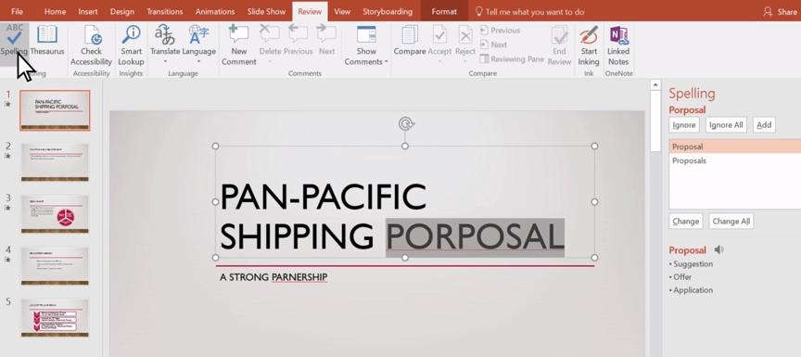

Add math to slides
PowerPoint makes adding equations to your slides simple.
Insert an equation
To insert a built-in equation, select Insert >Equation, and then choose the equation you want.
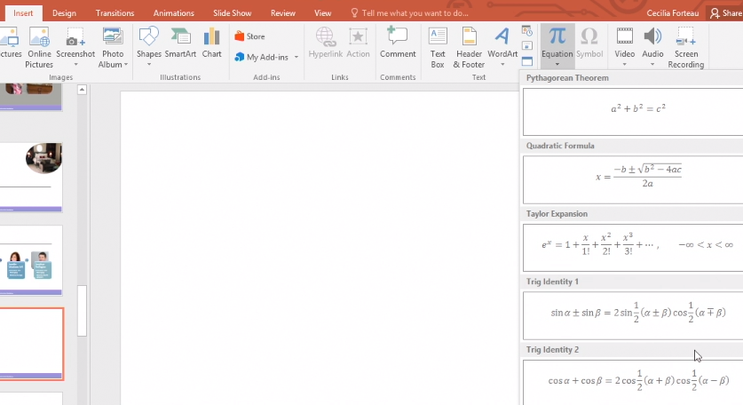
Or select Insert > Equation for a blank equation.
- Under the Equation Tools Design tab, select Fraction, Script, Radical, Integral, Operator, Function or Symbols to insert your elements into your equation.
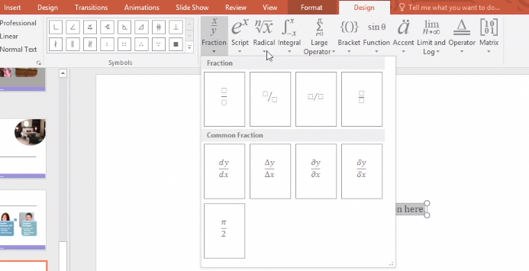
Create ink equations
- Select Ink Equation.
Note: Ink equations are ideally done with a stylus, but you can also use a mouse.
- Write in your equation, and then select Erase or Select and Correct to modify and choose which elements of your written equation to keep.
- To put your equation into PowerPoint, select Insert.
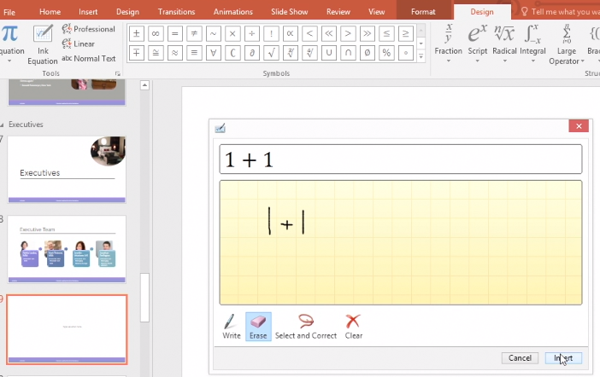

Import a Word outline into PowerPoint
If you've already jotted down an outline of your presentation in Word and now need a quick way to add it to your slides, you can import a Word outline into PowerPoint.
Create an outline in Word
- Open Word.
- Select View > Outline. This automatically generates an outline and opens the Outlining tools:
  - If your document has headings (any heading levels from H1-H9), you’ll see those headings organized by level.
  - If your document doesn’t have headings and subheadings yet, the outline will appear as a bulleted list with a separate bullet for each paragraph or body text. To assign or edit headings, heading levels, and set up your document structure:
    - Select a bulleted item.
    - In the Outline Level box, select a heading level as needed.
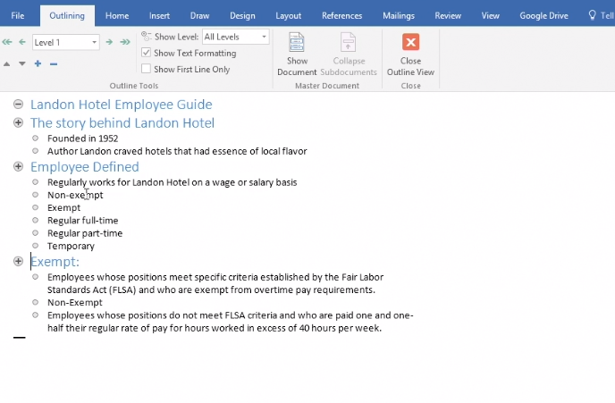
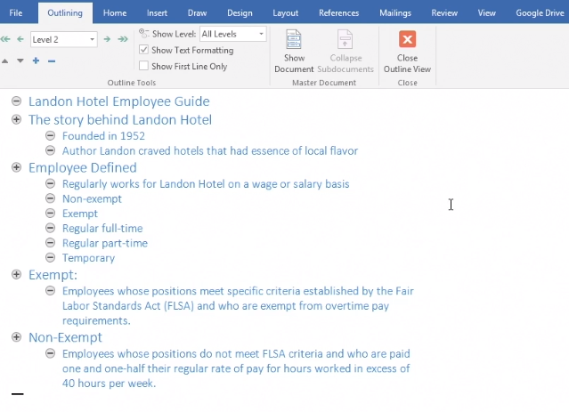
    - When finished or to edit your document, select Close Outline View.
Save an outline in Word
- To save your document, select Save, name your file, and then select Save once more. Select Close to close your document.
Note: Your Word document must be closed to insert it into a PowerPoint presentation.
Import a Word outline into PowerPoint
- Open PowerPoint, and select Home > New Slide.
- Select Slides from Outline.
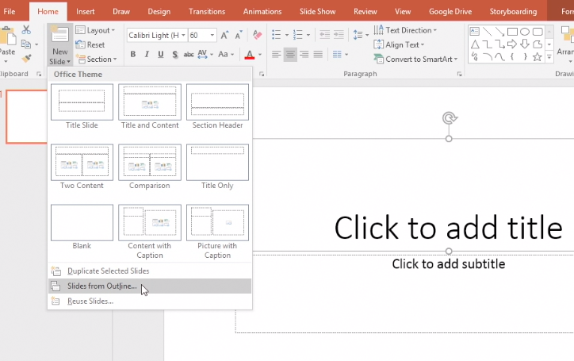
- In the Insert Outline dialog box, find and select your Word outline and select Insert.
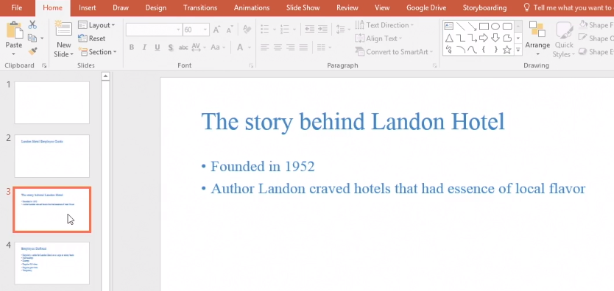
Note: If your Word document contains no Heading 1 or Heading 2 styles, PowerPoint will create a slide for each paragraph in your content.

Add hyperlinks to slides
Add links to your presentation to show related information on the web, quickly get to a different slide, or start an email message.
Link to a website
- Select the text, shape, or picture that you want to use as a hyperlink.
- Select Insert > Hyperlink.
- Select Existing File or Web Page, and add the:
  - Text to display - Type the text that you want to appear for your hyperlink.
  - ScreenTip - Type the text that you want to appear when the user hovers over the hyperlink (optional).
  - Current Folder, Browsed Pages, or Recent Files - Select where you want to link to.
  - Address - If you haven't already selected a location above, cut and paste, or type the URL for the web site you want to link to.
Note: If you link to a file on your computer, and move your PowerPoint presentation to another computer, you'll also need to move any linked files.
- Select OK.
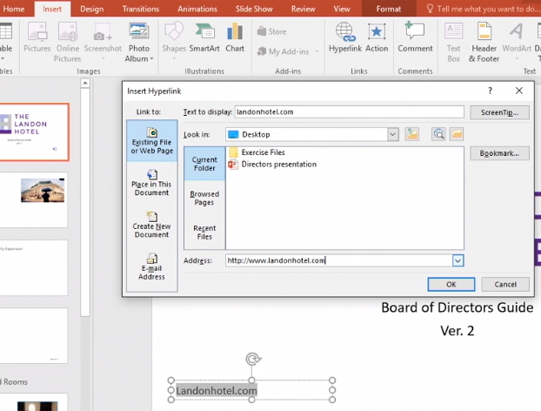
Link to a place in a document, new document, or email address
- Select the text, shape, or picture that you want to use as a hyperlink.
- Select Insert > Hyperlink and select an option:
  - Place in This Document - Link to a specific slide in your presentation.
  - Create New Document - Link from your presentation to another presentation.
  - E-mail Address - Link a displayed email address to open a user's email program.
- Fill in the Text to display, ScreenTip, and where you want to link to.
- Select OK.

Add SmartArt to a slide
Add SmartArt to your PowerPoint slides to create visual impact to your text and bullets.
Add SmartArt
- Select the text that you'd like to work with.
- Select Home > Convert to SmartArt, and then select a SmartArt graphic.
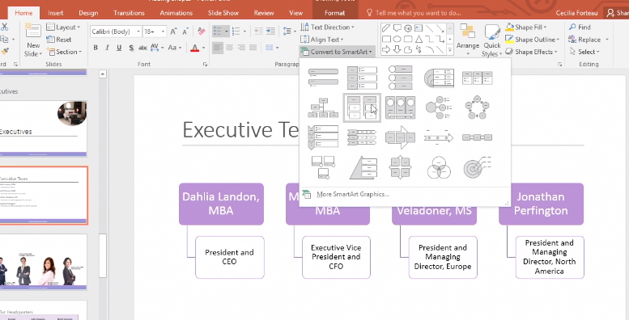
- Under the SmartArt Tools Design tab, you can choose from:
  - SmartArt Styles - Select a SmartArt style to apply to your slides.
  - Change Colors - Change colors of your SmartArt style.
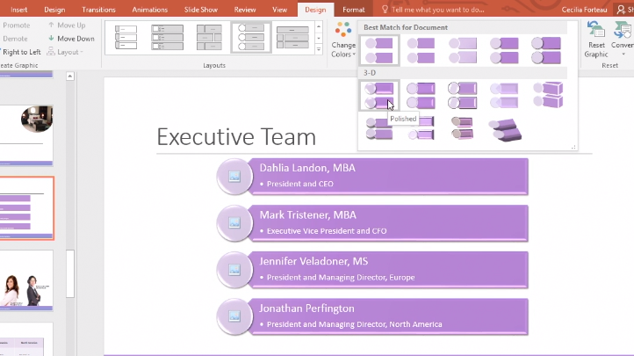
Add pictures to SmartArt
- Select the image placeholder inside your SmartArt.
- Select Browse, go to a photo you'd like to use, and select Insert.
If you'd like to format your photo, you can choose:
  - Crop - Crop your photo or use the tool to adjust your photo's fit in the placeholder. Select Crop to confirm the change.
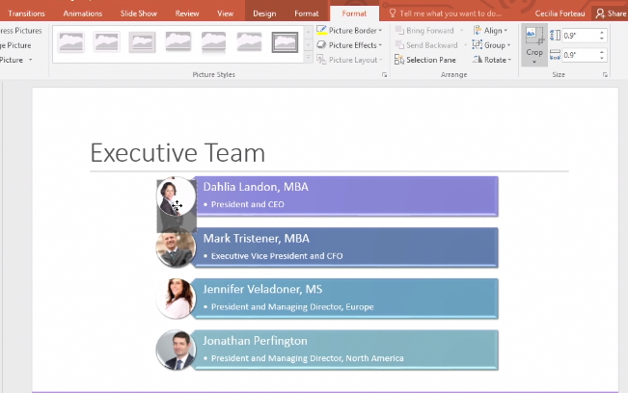
- If you'd like to change your selected SmartArt style, under the SmartArt Design tab, select the drop-down arrow for Layouts > More Layouts.
- Select a SmartArt style you like, such as Picture, and then select OK.
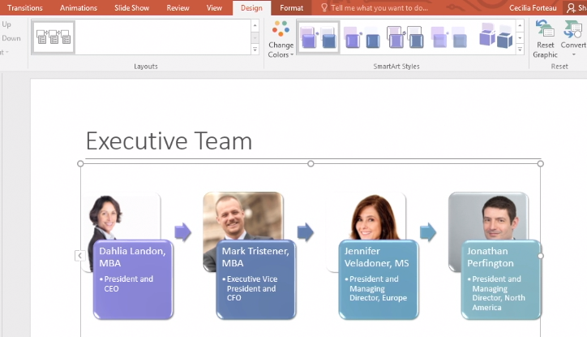

Add WordArt to a slide
Insert WordArt to visually transform your text and slides.
Add WordArt
- Select the text you'd like to work with.
- On the Drawing Tools Format tab, you can select WordArt Styles, Text Effects, and more to add style to your text.
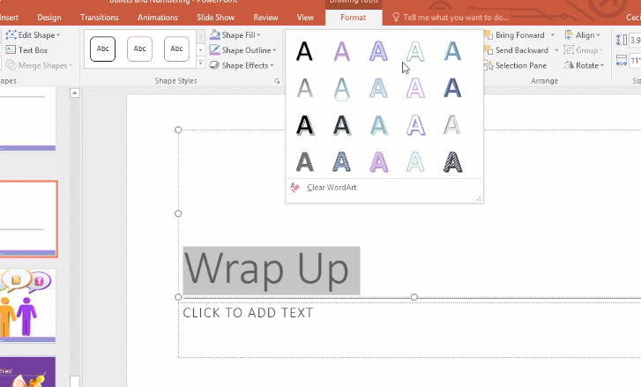
- Select Home > Reset if you'd like to undo all changes.
Edit an entire placeholder of text
- Select the text placeholder you'd like to edit.
- On the Drawing Tools Format tab, you can change the font properties for all text in the placeholder, such as the size, bolding, or color.
- Select the WordArt Styles drop-down arrow or select Text Effects to format text all at once.
